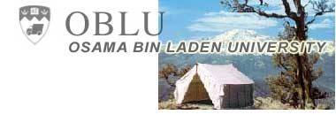

Commitment.Community.Jihad!
Osama bin Laden University seeks to instill the fundamentals of terrorism in its students. Whether you want the glorious martyrdom of killing hundreds of infidels in an embassy bombing, or the more personal satisfaction of hunting down a blasphemous author in a mullah-sanctioned fatwa, OBLU can get you where you want go!
If you can answer yes to even than half of the following, a career in terror may be for you!
Yes!
- I want to make a difference!
- I can handle a challenge!
- I can drive a truck!
- I want to wipe that smirk off George Bush's face!
- I enjoy waving guns around and firing them into the sky randomly at large rallies!
- I look good in a vest filled with explosives!
- I want a job that's to die for!

ABOUT US

CAMPUS

Located in the magnificently rugged mountains of Afghanistan, OBLU's campus ranks as one of the most beautiful educational settings in the world. Miles of running trails wend their way through the snowy passes. And keeping a sharp eye out for land mines keeps fitness buffs strong in both body and mind!

CURRICULUM
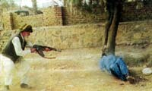
Long a source of pride for students, the OBLU honor code is strictly enforced

All our students start off with a solid basis in the core areas of modern terrorism. By the end of freshman year, you will know how to: lob stones effectively, burn flags without burning yourself, chant angry slogans for hours thanks to foot-friendly arch inserts, and much, much more!

By your junior year, you will have declared a major. You might learn to operate class "c" vehicles such as cars and light trucks. Or you could decide to master the art of docking with American Destroyers on an inflatable boat. If you're an advanced student, you might even get to study at the post-graduate level, trying to harvest the Ebola virus from bloody, dying monkeys with your bare hands!

FACULTY
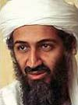
Dean bin Laden

Dean of School Osama bin Laden is the most universally recognized figure in world terror today. He has successfully brought down the Soviet Empire due to his acclaimed in Afghanistan, and now is continuing his work against the great Satan, America. With a $25 million dollar bounty on his head, Professor bin Laden must be doing something right!

TRAVEL OPPORTUNITIES & RECOGNITION

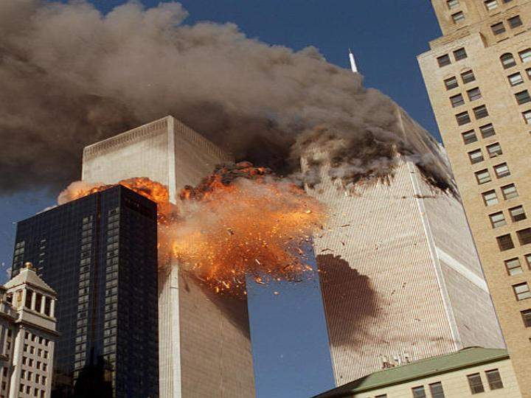
Recent graduate work in New York received worldwide attention

Recent graduates have gone to such exotic locales as Kashmir, Chechnya, Tel Aviv and even New York City! What better way to see the world than on a holy mission to destroy it?

"I used to just sit around and hate Americans. Now, I get the great personal satisfaction of doing something about it."
Junior, Majoring in Car Bombing

"I like the idea of going straight to paradise and all I have to do is get gunned down while killing Americans. Do the math. It's a no-brainer!"
Senior, Weapons Major

"I used to think making the streets run red with blood was just hyperbole. Now, I know that with a whole lot of elbow grease, and just a little bit of emtex in a truck, it can definitely be done!"
Junior, Chemistry Major

SOCIAL LIFE

Of course, OBLU is not just a "terror factory." From volleyball to tetherball, students enjoy a variety of social and enrichment events outside of their daily Jihad duties. Many of the friendships made at school are strong enough to last for all eternity in the hall of martyrs!

OBLU students also enjoy these perks:
- Graduates receive no-money down loan for all truck or boat purchases
- 50% discount on all weapons purchases made at the student store
- Free parking

Apply today for Osama bin Laden University.
Still unsure? Take our OBLU-sanctioned extension course, "the How-To's of International Terrorism," offered at a Learning Annex near you.

Contact our SAARC region representative for more details and admission information:
Gen. Pervez Musharraf
Bunker No. 786,
Khandahar - Afghanistan
Tel: 1600 – 475654

